**Assignment 5 by Script –**

**Script –**

pipeline {

agent{

label{

label 'slave-1'

customWorkspace'/root/target'

}

}

tools {

maven 'apache-maven-3.9.9'

}

stages{

stage('one'){

steps{

git branch: 'master' , url: "https://github.com/Shantanumajan6/project.git"

sh" mvn clean install "

sh '''

sudo cp /root/target/target/LoginWebApp.war /root/server/apache-tomcat-10.1.40/webapps

'''

}

}

}

}

Explanation - The Jenkins pipeline on the slave-1 node automates the process of building and deploying the **LoginWebApp** to an Apache Tomcat server. It begins by checking out the project from the GitHub repository at https://github.com/Shantanumajan6/project.git. Using Maven (apache-maven-3.9.9), it executes mvn clean install to compile the application and generate the LoginWebApp.war file. Subsequently, the pipeline copies the .war file to the Tomcat server's webapps directory, triggering the deployment of the application. This setup ensures a streamlined and automated deployment process for the LoginWebApp.

Final Output –

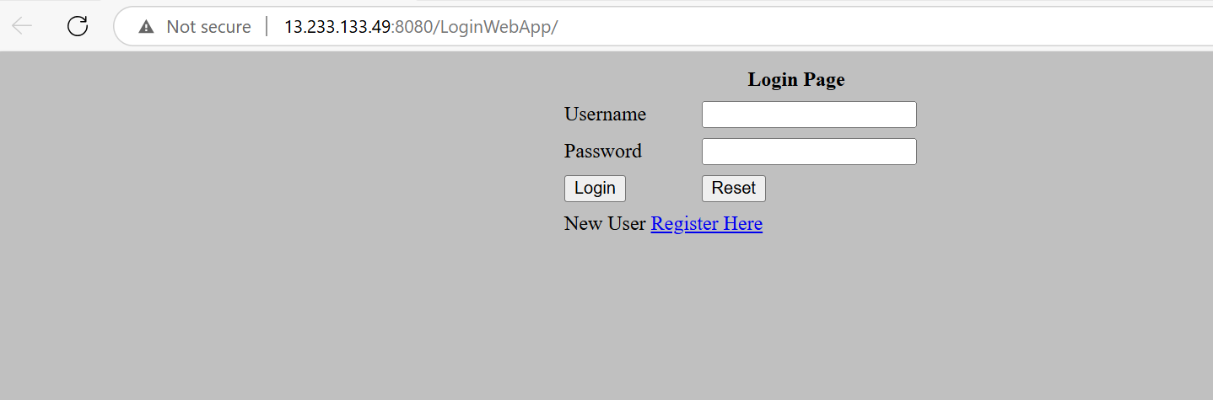

Console Outputs –

